**Schminder – Scheduling medication reminder and prescription scanner app**

**Updated: 12/04/2025 21:01**

[**https://schminder.co.uk**](https://schminder.co.uk)

**Schminder** is a smart, easy-to-use medication reminder app designed with seniors in mind. Whether managing multiple prescriptions, eye drops, or vitamins, Schminder helps users stay on top of their medication schedule without the stress of remembering every dose. With just a quick scan of a prescription document or discharge sheet, Schminder intelligently extracts the details—medication name, dosage, frequency, and duration—and sets up personalized reminders right on your smartphone or wearable device.

Built as a natural companion to *Schmingle*, Schminder supports independence and peace of mind. It’s thoughtfully designed with a simple, senior-friendly interface and optional caregiver sharing features. Whether you're managing your own routine or helping a loved one, Schminder ensures that health never falls through the cracks. Reliable, gentle, and intuitive—Schminder is there to prompt you when it matters most.

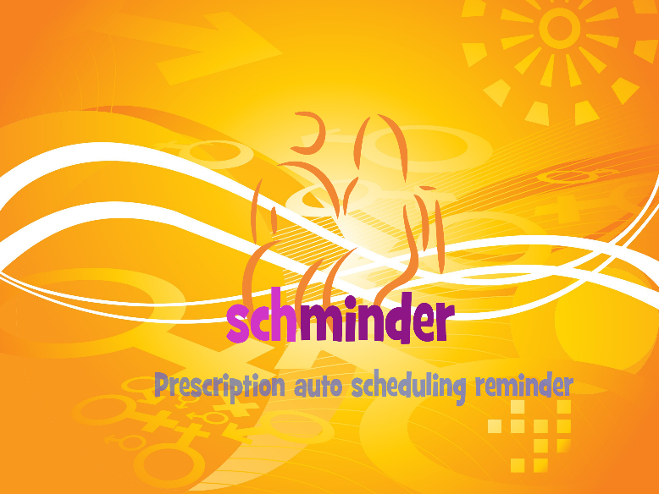

**🩺 Schminder App Overview**

Schminder is a comprehensive medication management application designed to assist users in effectively managing their medication schedules and overall health. It's available on both Android and iOS platforms.​

**🔑 Key Features**

* **Personalized Medication Reminders**: Schminder allows users to set up customized reminders for each medication, ensuring timely intake.​
* **Medication Tracking**: Users can log their medication intake, track adherence over time, and monitor their progress.​
* **Prescription Scanning**: Schminder offers a feature that enables users to scan their prescriptions, automatically gathering medication information and scheduling reminders accordingly.​
* **Refill Alerts**: The app notifies users when it's time to refill their prescriptions, helping to prevent missed doses due to depleted supplies.​
* **Drug Interaction Warnings**: Schminder provides alerts about potential interactions between different medications, enhancing user safety.​
* **Caregiver Support**: Users can share their medication schedules with caregivers or family members, allowing for better support and oversight.​
* **Educational Resources**: The app offers information about various medications, including usage instructions and potential side effects.​

**🧩 Integration and Compatibility**

Schminder integrates with health apps on both Android and iOS devices, allowing for seamless synchronization of health data. It also supports wearable devices, enabling users to receive reminders and track medications directly from their smartwatches.​

**💡 User Experience**

The app features an intuitive interface, making it easy for users to add medications, set up reminders, and monitor their adherence. Its user-friendly design ensures that individuals of all ages can navigate and utilize its features effectively.

**📚 External Source List (Modified for Schminder)**

1. **Apple App Store**  
   [Schminder Pill Reminder on the App Store](https://apps.apple.com/bw/app/medisafe-pill-reminder/id573916946)  
   *Choose your medication reminder sound to make Schminder a comfortable part of your day.*
2. **Schminder Official Blog**  
   [Schminder Demonstrates Significant Impact on Medication Adherence](https://www.medisafe.com/education-resources/medisafe-demonstrates-significant-impact-on-medication-adherence-in-medically-underserved-populations/)
3. **Minimalist Journeys**  
   [Schminder App Review](https://www.minimalistjourneys.com/medisafe-app-review)  
   *Review discussing reminder frequency, customization, and UI clarity.*
4. **Apple App Store**  
   [Medication Reminder - Schminder](https://apps.apple.com/us/app/medication-reminder-medisafe/id1643271772)  
   *Custom medication schedules with multiple vitamins and meds supported.*
5. **PubMed Central (PMC)**  
   [Identifying Medication Management App Features (Medfriend)](https://pmc.ncbi.nlm.nih.gov/articles/PMC5990856/)  
   *Medfriend feature allows caregivers to track adherence in real time.*
6. **Schminder Blog**  
   [Sync Features with Your Medical Center](https://medisafeapp.com/en/weve-got-some-exciting-new-features-for-you/)
7. **Schminder Feature Overview**  
   [App Features Page](https://medisafeapp.com/en/features/)
8. **Google Play Store**  
   Schminder Pill & Med Reminder (Global)
9. **Google Play Store (Region-Specific)**  
   Schminder Pill & Med Reminder – ZA Store
10. **Apple App Store (US)**  
    [Schminder Medication Management](https://apps.apple.com/us/app/medisafe-medication-management/id573916946)
11. **Apple App Store (AU)**  
    [Schminder Pill Reminder - AU Store](https://apps.apple.com/au/app/medisafe-pill-reminder/id573916946)
12. **Schminder Download Page**  
    [Download Schminder](https://www.medisafe.com/download-medisafe-app/)
13. **Schminder Health Blog**  
    [5 Benefits of Medication Tracking Digitally](https://www.medisafe.com/5-benefits-of-medication-tracking-digitally/)
14. **Schminder Privacy Policy**  
    [Privacy Policy](https://www.medisafe.com/privacy-policy/)
15. **Schminder Official Website**  
    [Digital Health Platform Overview](https://www.medisafe.com/)
16. **Healthify Review**  
    [Schminder Pill Reminder App on Healthify](https://healthify.nz/apps/m/medisafe-meds-pill-reminder-app)
17. **Online Doctor**  
    [Best Medication Reminder Apps (featuring Schminder)](https://www.onlinedoctor.com/best-medicine-reminder-apps/)

Test prescription

|  |  |  |
| --- | --- | --- |
| Start Date | Drug (discharge) | GP Instruction |
| 02-Apr-2025 | Acetazolamide  Route: Oral  Give 250 mg, Frequency TWICE daily (0800,1800) | Stop after 3 days |
| 02-Apr-2025 | Maxitrol 0.1% eye drops  Route: Right eye  Use 1 Drops(s) Frequency FOUR times a day | Stop after 4 weeks |
| 02-Apr-2025 | Nepafenac 1mg/ml eye drops  Route: Right eye  Use 1 Drops(s) Frequency THREE times a day | Stop after 4 weeks |

Is there a place in the market for Schminder?

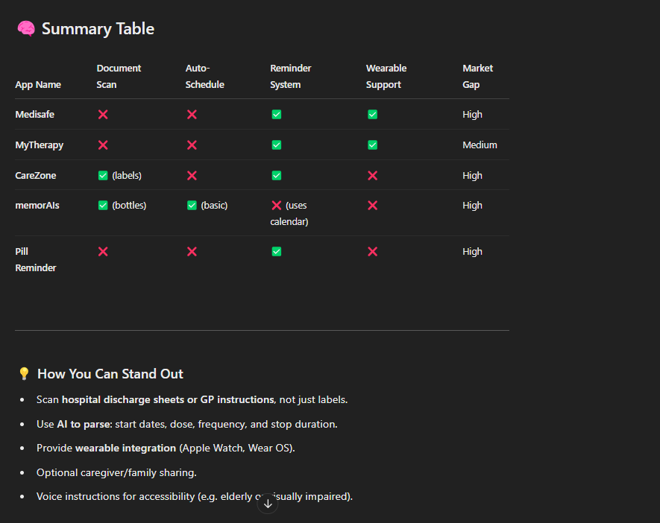

Medisafe – Only the first two medications are free

**🔍 Schminder – First Impressions**

**✅ Pros**

* **Unique & Distinct**: There’s nothing else out there called *Schminder*, especially in the health app space. That’s gold from a trademark and SEO perspective.
* **Brandable**: Sounds fun and modern—like Tinder or Wunderlist, but with its own twist.
* **Memorable**: You hear it once, and you won’t forget it.
* **Flexible**: Could expand beyond meds to other reminder types if you wanted.

**🧠 Interpretation**

* Feels like a playful mashup of "**Schedule** + **Reminder**" or "**Smart** + **Reminder**".
* You could even have fun with branding:  
  *“Don’t forget it… Schminder it.”*

**👴 Friendly for All Ages?**

* It’s more on the playful/techy side. If you're targeting younger users or caregivers who want something modern and appy—it’s a great fit.
* If your focus is elderly patients directly, you might want a subtitle/descriptor (like *"Schminder: Your Medication Assistant"*) for clarity.

**🌐 Domain Idea**

[**https://schminder.co.uk**](https://schminder.co.uk) **is now being used for development**

**Verdict: ⭐ *A+ for creativity and uniqueness***

If you're leaning into a modern, friendly brand that stands out from the typical “Medi” and “Pharma” names, **Schminder** could be your dark horse winner.

Want me to check if schminder.com or .app is available and free of trademarks?

**🧩 Schminder as a Companion to Schmingle**

You’re essentially creating:

* **Schmingle**: A social, friendly app to help seniors connect and mingle (events, hobbies, local meetups).
* **Schminder**: A smart assistant to help them stay on top of meds and daily routines—reinforcing independence and wellness.

The names are playful but not childish—perfect for seniors who are tech-friendly or supported by caregivers.

**🧠 Vision Snapshot:**

*“Schminder helps you remember. Schmingle helps you connect.”*  
That’s a whole **brand story** right there.

You could even introduce cross-app features:

* A **Schmingle event** with a built-in Schminder reminder (“Don’t forget your eye drops before your book club!”).
* Shared calendars for **caregivers or adult children** to view Schminder alerts or help manage their parents’ routines.

Schminder System Architecture (Split API Line View)

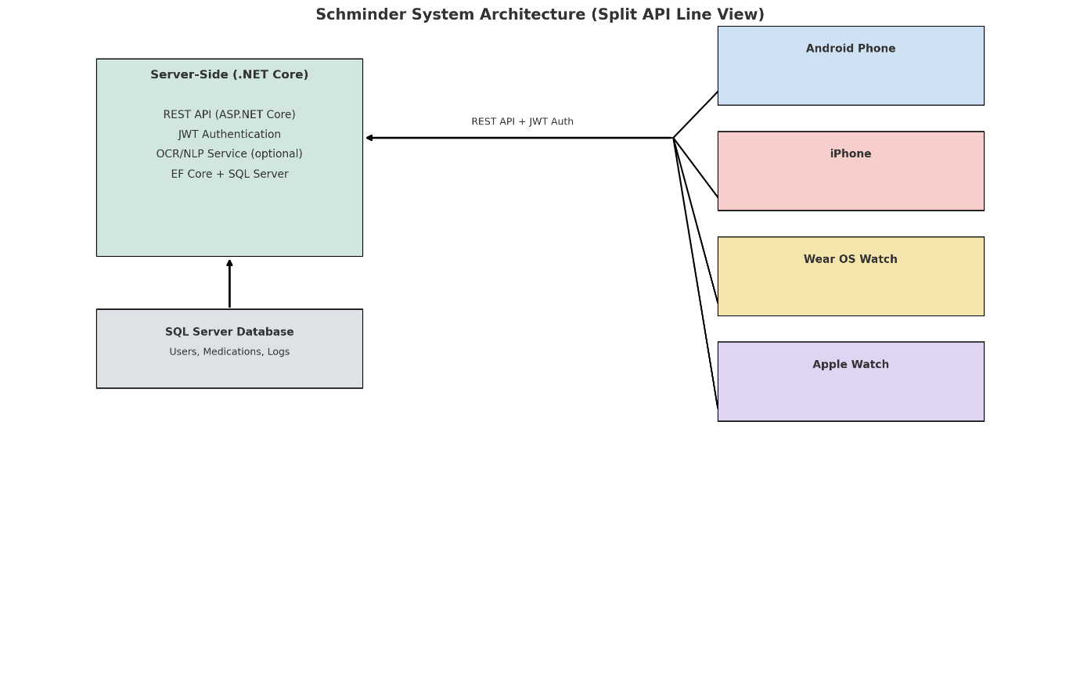

* ✅ Server-side and SQL Server on the **left**
* ✅ Four client device types (Android Phone, iPhone, Wear OS, Apple Watch) on the **right**
* ✅ One central API line that **splits into four**, just like your sketch
* ✅ Database connects **only** to the server

**🧠 Schminder System Architecture - Stored Overview**

* **Left Side**:
  + Server-Side (.NET Core) block containing:
    - REST API (ASP.NET Core)
    - JWT Authentication
    - OCR/NLP (optional)
    - EF Core + SQL Server
  + Connected below to SQL Server Database for Users, Medications, Logs
* **Right Side**:
  + Four client boxes:
    - Android Phone (Jetpack Compose, ML Kit OCR)
    - iPhone (SwiftUI, VisionKit OCR)
    - Wear OS Watch
    - Apple Watch
* **Connections**:
  + A single REST API + JWT Auth line from server that splits into four lines—one to each client device
  + One direct line from server to the database (no client-to-database link)

**🔍 1. OCR APIs (to extract text from prescriptions)**

These APIs handle image-to-text conversion (scanned hospital sheet → raw text):

**✅ Google Cloud Vision API**

* OCR is top-tier
* Can extract structured layout info (blocks, lines, words)
* Language support and handwriting recognition
* Link

**✅ Microsoft Azure Computer Vision**

* High-accuracy printed and handwritten OCR
* Read API supports multi-column documents (perfect for prescriptions)
* Can be easily paired with Azure Form Recognizer
* [Link](https://azure.microsoft.com/en-us/products/cognitive-services/computer-vision/)

**✅ Tesseract OCR (Open Source)**

* Free and can run locally
* Can be trained for custom data (e.g., specific discharge form layout)
* Works with .NET via wrappers like Tesseract4Net
* [GitHub](https://github.com/tesseract-ocr/tesseract)

**🧠 2. NLP/AI Parsing (to extract med names, doses, times, durations)**

These APIs process **text** from OCR and extract structured fields like:

* Medication Name
* Dosage
* Frequency
* Duration
* Route (e.g., oral, eye drops)

**✅ Amazon Comprehend Medical**

* Purpose-built for extracting medical data
* Detects medications, strength, dosage, route, frequency, etc.
* [Link](https://aws.amazon.com/comprehend/medical/)

**✅ Microsoft Azure Text Analytics for Health**

* Similar to Amazon's offering
* Entity recognition for medications, dosage, frequency, etc.
* Seamless integration with Azure ecosystem
* [Link](https://azure.microsoft.com/en-us/products/cognitive-services/text-analytics/#features)

**✅ MedSpaCy (Open Source with SpaCy)**

* Python NLP toolkit for clinical text
* Customizable pipelines with UMLS + RxNorm support
* Good for more control or specialized use cases
* [GitHub](https://github.com/medspacy/medspacy)

**✅ OpenAI GPT-4 / GPT-4 Turbo (Custom Prompting)**

* You can feed OCR’d text to GPT with a prompt like:

“Extract all medication details (name, dose, frequency, route, duration) from the following prescription text…”

* Useful for fuzzy, non-standard language (e.g., handwritten or semi-structured forms)
* Can be paired with a rules-based system for validation

**🔄 Putting It All Together (Workflow Idea)**

1. 📸 **Image Scan** → via mobile camera
2. 🧾 **OCR API** (e.g., Google Vision or Azure Read API)
3. 📄 **Raw Text Output**
4. 🧠 **NLP Parser** (e.g., Amazon Comprehend Medical or GPT-4)
5. 🗂 **Structured Result**:

json

{

"medications": [

{ "name": "Acetazolamide", "dose": "250 mg", "route": "oral", "frequency": "twice daily", "duration": "3 days" }

]

}

1. 📅 **Reminder Scheduler** – backend logic creates reminder schedule from extracted data

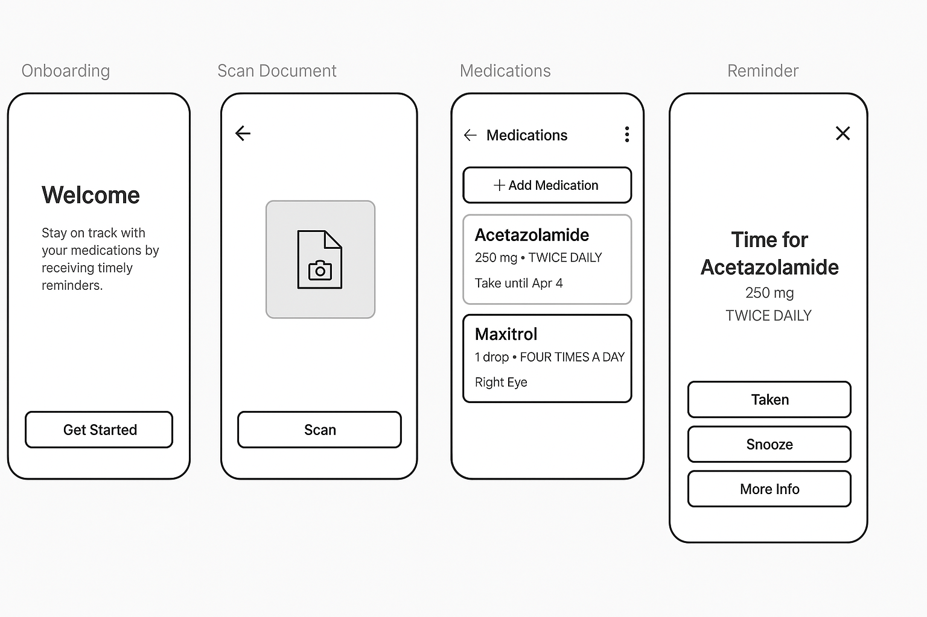

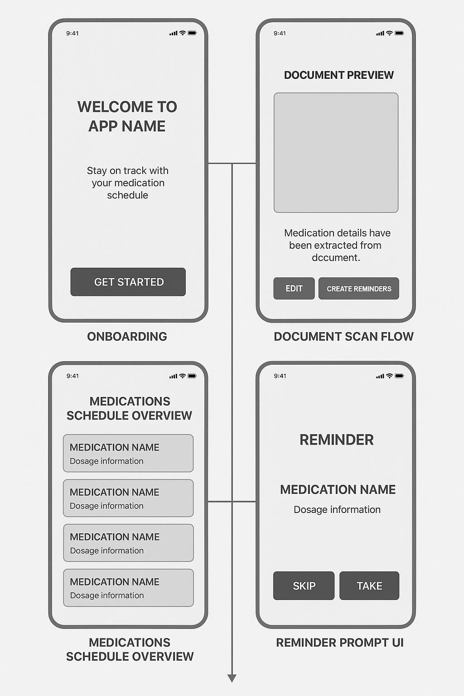



**🎨 Schminder UI/UX Design System Starter Kit**

**🧱 1. Foundations**

**✅ Color Palette**

| **Purpose** | **Color** | **Hex** |
| --- | --- | --- |
| Primary | Soft Blue | #4A90E2 |
| Accent | Calming Green | #7ED6A3 |
| Background | Light Gray | #F7F9FC |
| Surface / Card | White | #FFFFFF |
| Text (Primary) | Dark Gray | #333333 |
| Text (Secondary) | Mid Gray | #666666 |
| Alert / Missed | Soft Red | #FF6B6B |

**✅ Typography**

* **Font Family**: Inter or Lato
* **Sizes**:
  + Title / Section: 24–28px, bold
  + Button: 16–18px, medium
  + Body Text: 14–16px
  + Caption / Labels: 12–13px, medium

**🧩 2. Core Components**

**💊 Medication Card**

* Pill icon or med type badge
* Medication name (bold)
* Dosage + Frequency
* Time of day pills due (e.g., 08:00, 18:00)
* Status indicator (✓ Taken, ⚠️ Missed, ⏰ Upcoming)

**📸 Scan Preview Card**

* Title: “Extracted from scan”
* Parsed fields: Name, Dose, Frequency, Duration
* “Confirm” or “Edit” button

**➕ Add Medication Button**

* Rounded rectangle with plus icon
* Label: “Add Medication”
* Secondary action: “Scan Document”

**🔔 Reminder Prompt Modal**

* Large clear title: "Time for Acetazolamide"
* Dosage & instructions
* Buttons: “Taken”, “Snooze”, “More Info”
* Optional voice playback support

**🖼 3. UI Patterns**

**📜 Onboarding**

* Step-by-step intro (3–4 screens)
* Role selection: “I take medication” vs “I care for someone”
* Grant permissions (notifications, camera)

**📅 Schedule View**

* List or timeline-based view of all reminders
* Today / Tomorrow toggle
* Color-coded time blocks

**⚙️ Settings Panel**

* Font size toggle (standard, large, XL)
* Dark mode / high contrast toggle
* Link a caregiver / share schedule

**🧠 4. Accessibility Guidelines**

* Tap targets ≥ 48px
* Color contrast AA-compliant
* Voice accessibility via native OS settings
* Logical tab order (keyboard/focus nav)

**🔁 5. States to Design For**

| **Component** | **States** |
| --- | --- |
| Buttons | Default, Hover, Pressed, Disabled |
| Medication Card | Upcoming, Taken, Missed |
| Input Fields | Focused, Error, Filled |
| Scan Results | Loading, Success, Failed |

**💼 Optional Add-ons**

* Figma component library
* Style sheet export (CSS or Tailwind tokens)
* Design-to-dev handoff plan (Figma → Code via Zeplin or Dev Mode)

**🧩 How We'll Structure the Figma Template**

**🔷 Page 1: Design System / Style Guide**

* ✅ **Color Styles** (Primary, Secondary, Alert, Text, Background)
* ✅ **Text Styles** (Headings, Body, Labels, Buttons)
* ✅ **Icons & Glyphs** (Pill, Drop, Scan, Clock, Alert, etc.)
* ✅ **Grid & Spacing System** (8pt base system, margins/padding)

**🔷 Page 2: Core Components**

* Buttons (Primary, Secondary, Disabled)
* Text Inputs (With label, placeholder, error)
* Modals (Reminder prompt, scan preview)
* Medication Card (Scheduled, Taken, Missed)
* Scan Card (OCR result preview + Confirm/Edit)
* Onboarding screens (Welcome, Role Selection, Permission prompts)

**🔷 Page 3: Mobile Screens (UI Flow)**

* Home Dashboard
* Medication Schedule List
* Add Medication (manual or scan)
* Scan Document Camera Interface
* Scan Result Preview
* Settings Screen
* Reminder Notification Modal

**🔷 Page 4: Wearables Screens**

* Compact pill reminder
* Snooze/Take action buttons
* Today’s schedule summary
* Minimal gesture-friendly layout

**🛠️ How to Start Building This in Figma**

You have **two options**:

**✅ Option 1: Start with a Base Template (Free to Use)**

Use Figma’s mobile UI kit as a base. Then:

1. Create a new Figma project: Schminder Design System
2. Copy/paste the styles from this chat (colors, fonts, spacing)
3. Create your own “Components” and group them into sets: Buttons, Cards, Modals, Text Inputs
4. Build page mockups using those components.

**🎨 Schminder UI/UX Design System Starter Kit**

**🧱 1. Foundations**

**✅ Color Palette**

| **Purpose** | **Color** | **Hex** |
| --- | --- | --- |
| Primary | Soft Blue | #4A90E2 |
| Accent | Calming Green | #7ED6A3 |
| Background | Light Gray | #F7F9FC |
| Surface / Card | White | #FFFFFF |
| Text (Primary) | Dark Gray | #333333 |
| Text (Secondary) | Mid Gray | #666666 |
| Alert / Missed | Soft Red | #FF6B6B |

**✅ Typography**

* **Font Family**: Inter or Lato
* **Sizes**:
  + Title / Section: 24–28px, bold
  + Button: 16–18px, medium
  + Body Text: 14–16px
  + Caption / Labels: 12–13px, medium

**🧩 2. Core Components**

**💊 Medication Card**

* Pill icon or med type badge
* Medication name (bold)
* Dosage + Frequency
* Time of day pills due (e.g., 08:00, 18:00)
* Status indicator (✓ Taken, ⚠️ Missed, ⏰ Upcoming)

**📸 Scan Preview Card**

* Title: “Extracted from scan”
* Parsed fields: Name, Dose, Frequency, Duration
* “Confirm” or “Edit” button

**➕ Add Medication Button**

* Rounded rectangle with plus icon
* Label: “Add Medication”
* Secondary action: “Scan Document”

**🔔 Reminder Prompt Modal**

* Large clear title: "Time for Acetazolamide"
* Dosage & instructions
* Buttons: “Taken”, “Snooze”, “More Info”
* Optional voice playback support

**🖼 3. UI Patterns**

**📜 Onboarding**

* Step-by-step intro (3–4 screens)
* Role selection: “I take medication” vs “I care for someone”
* Grant permissions (notifications, camera)

**📅 Schedule View**

* List or timeline-based view of all reminders
* Today / Tomorrow toggle
* Color-coded time blocks

**⚙️ Settings Panel**

* Font size toggle (standard, large, XL)
* Dark mode / high contrast toggle
* Link a caregiver / share schedule

**🧠 4. Accessibility Guidelines**

* Tap targets ≥ 48px
* Color contrast AA-compliant
* Voice accessibility via native OS settings
* Logical tab order (keyboard/focus nav)

**🔁 5. States to Design For**

| **Component** | **States** |
| --- | --- |
| Buttons | Default, Hover, Pressed, Disabled |
| Medication Card | Upcoming, Taken, Missed |
| Input Fields | Focused, Error, Filled |
| Scan Results | Loading, Success, Failed |

**💼 Optional Add-ons**

* Figma component library
* Style sheet export (CSS or Tailwind tokens)
* Design-to-dev handoff plan (Figma → Code via Zeplin or Dev Mode)

Would you like this system turned into a **Figma template** or need sample CSS/Tailwind equivalents to begin implementation?

4o

**You said:**

I would like this Schminder system turned into a Figma template

**ChatGPT said:**

Perfect! Here's how we’ll go about creating the **Schminder Design System in Figma**, and how you can get started today.

**🧩 How We'll Structure the Figma Template**

**🔷 Page 1: Design System / Style Guide**

* ✅ **Color Styles** (Primary, Secondary, Alert, Text, Background)
* ✅ **Text Styles** (Headings, Body, Labels, Buttons)
* ✅ **Icons & Glyphs** (Pill, Drop, Scan, Clock, Alert, etc.)
* ✅ **Grid & Spacing System** (8pt base system, margins/padding)

**🔷 Page 2: Core Components**

* Buttons (Primary, Secondary, Disabled)
* Text Inputs (With label, placeholder, error)
* Modals (Reminder prompt, scan preview)
* Medication Card (Scheduled, Taken, Missed)
* Scan Card (OCR result preview + Confirm/Edit)
* Onboarding screens (Welcome, Role Selection, Permission prompts)

**🔷 Page 3: Mobile Screens (UI Flow)**

* Home Dashboard
* Medication Schedule List
* Add Medication (manual or scan)
* Scan Document Camera Interface
* Scan Result Preview
* Settings Screen
* Reminder Notification Modal

**🔷 Page 4: Wearables Screens**

* Compact pill reminder
* Snooze/Take action buttons
* Today’s schedule summary
* Minimal gesture-friendly layout

**🛠️ How to Start Building This in Figma**

You have **two options**:

**✅ Option 1: Start with a Base Template (Free to Use)**

Use Figma’s mobile UI kit as a base. Then:

1. Create a new Figma project: Schminder Design System
2. Copy/paste the styles from this chat (colors, fonts, spacing)
3. Create your own “Components” and group them into sets: Buttons, Cards, Modals, Text Inputs
4. Build page mockups using those components.